.data

prompt: .asciiz "Enter lenght for table: "

prompt1: .asciiz "Enter table : "

tab: .asciiz " : "

tab1: .asciiz "\n"

.text

.globl main

main:

la $a0,prompt

li $v0,4

syscall

li $v0,5

syscall

move $t0,$v0

la $a0,prompt1

li $v0,4

syscall

li $v0,5

syscall

move $t5,$v0

true:

bgtz $t0,lop

b exit

lop:

addi $t1,$t1,1

mul $t3,$t1,$t5

move $a0,$t1

li $v0,1

syscall

la $a0,tab # print tab

li $v0,4

syscall

move $a0,$t3

li $v0,1

syscall

la $a0,tab1 # print tab

li $v0,4

syscall

subi $t0,$t0,1

b true

exit:

li $v0,10

syscall

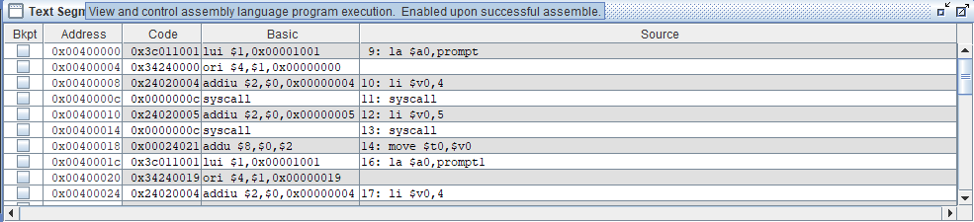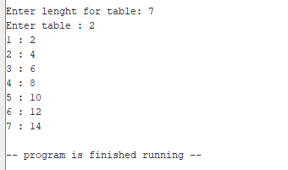

**.data**

**promt:.asciiz"Enter number : "**

**line:.asciiz"\n"**

**.text**

**.globl main**

**main:**

**li $v0,4**

**la $a0,promt**

**syscall**

**li $v0,5**

**syscall**

**move $t3,$v0**

**li $t0,0**

**li $t1,1**

**loop:**

**add $t0,$t0,$t1**

**move $a0,$t0**

**li $v0,1**

**syscall**

**li $v0,4**

**la $a0,line**

**syscall**

**addi $t1,$t1+1**

**blt $t1,$t3,loop**

**li $v0,10**

**syscall**

